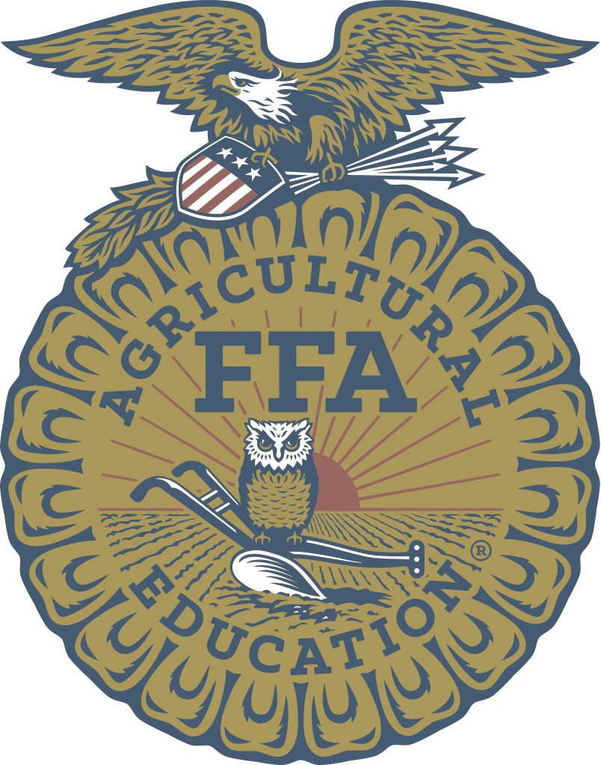
Santa Maria FFA Boosters
Agricultural Education Scholarship Application

- Scholarship Funds will be awarded to the most qualified applicant(s).
- The winning applicants will be selected by the Santa Maria FFA Boosters Scholarship Committee.
- Involvement in the following areas and it MUST be signed off by their Agricultural Advisor.
- Agricultural Class Work
- FFA Involvement
- SAE (Supervised Agricultural Experience)
- Attach a copy of AET Complete Record Book Report
- The Applicant MUST meet the following requirements:
- Applicant MUST be a Senior of Santa Maria High School.
- Applicant MUST fulfill entrance requirements of an accredited college/ university, junior/ community college or trade school.
- Applicant MUST be enrolled in an agricultural or agricultural related major.
- Applicant MUST be enrolled as a full-time student while in college or trade school (8 units.)
- A sealed, official transcript MUST accompany the application.
- A personal Interview may be requested.
- The Completed application, Letter of Recommendation and sealed Official Transcript MUST be postmarked or handed to your FFA Advisor by March 30th of each year. Address is listed below.
- Additional pages may be added as needed or attached to resume (optional)

Please Note:
Scholarship Winner(s) must send proof of enrollment in agriculture at a college, university or trade school to the Santa Maria FFA Boosters by February 1st of the following school year. If proof of enrollment is not sent the scholarship will be considered forfeited.

Mail Application Package to: Santa Maria FFA Boosters
PO Box 883
Santa Maria, CA 93455
Attn: Scholarship Committee

Applicant Information:

Name: Age:

Address:

City: State: Zip Code:

Home Phone Number: Cell Phone Number:

Father’s Name: Mother’s Name:

Please list junior colleges, universities and trade schools you plan to attend with course study:
Junior College |  | Course of Study
Junior College |  | Course of Study
University |  | Course of Study
University |  | Course of Study
University |  | Course of Study
Trade School |  | Course of Study
Trade School |  | Course of Study

For each of the prompts below, answer each of the questions to the best of your ability. Be as specific and thorough as possible. Attach additional sheets of paper if needed.
Prompt 1: Describe your agricultural course work. Include past classes taken and ones in which you are currently enrolled.

Prompt 2: Describe your involvement in the FFA Organization. Include activities at the Chapter, Sectional, Regional, State, and National level.

Prompt 3: Describe your SAE (Supervised Agricultural Experience) Projects. Include placement ownership, and entrepreneurship projects.

Prompt 4: Describe your involvement in community service activities. Include activities both within and outside of the Santa Maria FFA.

Prompt 5: What are your plans for the future? Think about where you would like to be between now and the next ten years.

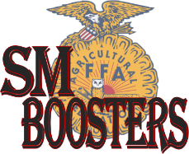
Santa Maria FFA Boosters
Agricultural Education Scholarship Application

As the Santa Maria FFA Advisor, I acknowledge that the above statements made by the candidate on this application regarding his/ her Agricultural related Class Work, FFA Involvement and SAE Project(s) are true and correct to the best of my knowledge.

Santa Maria FFA Ag Advisor’s Signature |  | Print Name

Date Signed

======================================================================
(Leave this section blank for use by the Scholarship Committee)

Revised: 1/1/2019

